GEARS

Gears are similar to belts and pulleys but have two major differences.

• The gears interlock or mesh together.
• The gear wheels in contact move in opposite directions.

As with pulleys, a large driving cog gives a distance advantage and a force disadvantage.

The opposite is true for a small driving cog.

Examples

Old watches and clocks used a gear system to keep time.

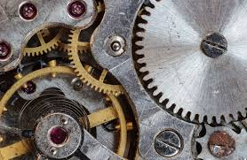

Most bicycles now have a back sprocket with many cogs. The chain attaches to the driving cog attached to the pedals.

